Is real-time transit information helpful? Analyzing the impacts of public transit real-time information on users waiting time

Luyu Liu and Harvey J. Miller

Department of Geography and Center for Urban and Regional Analysis

The Ohio State University

**Abstract:**

Real-time information (RTI) apps in public transit systems intend to reduce waiting times by allowing passengers to appropriately time their arrivals at transit stops. Although previous research surveyed and simulated the overall impact on certain stops, few studies investigate the impact’s mechanism and its spatiotemporal pattern. In this paper, we first introduce several trip planning strategies (TPSs) for both RTI and non-RTI users’ incidence behavior and corresponding quantitative descriptions. We also theorize and later validate the concept of reclaimed delay and discontinuity delay during the synchronization process. Then, with the support of GTFS real-time data, we optimize the RTI-based *prudent tactic* TPS and calculate the waiting time for each TPSs. Moreover, we compare different TPSs to measure RTI’s waiting time reduction. The results prove that RTI apps using the optimized *prudent tactic* can decrease waiting time for some users, however, it shows great variation geographically and temporally and cannot achieve global optimality for all stops. It also shows that RTI apps using the *greedy tactic* TPS will make users wait significantly longer than the bus delay, even longer than those who leave home randomly.

**Keywords:** Transit real-time information; GTFS; waiting time; mobile apps.

1. **Introduction**

Capabilities for collecting data and sharing real-time information about transportation systems is changing how people navigate and travel through cities. For example, apps and services such as Google Traffic, INRIX and Waze provide departure time and route suggestions for automobile-based travel based on current and predicted traffic and travel times, allowing users to avoid traffic congestion, minimize travel time and arrive on-time more frequently (Cabannes et al., 2018). Correspondingly, many public transit agencies are sharing schedule and real-time vehicle location data to enable navigation apps that make public transit more convivial and useful to users.

Public transit navigation apps allow users to discover and navigate public transit systems with complex routes and schedules (Dutzik, Madsen, & Baxandall, 2013). Public transit apps often provide real-time information (RTI) on vehicle locations and delays to help users to deal with this inevitable feature of public transit (Brakewood et al., 2014). In particular, RTI can allow users to reduce the amount of time they must wait for public transit at stops; this is crucial since wait time is perceived as onerous by users and cited as a major reason why people do not like using public transit (Algers, Hansen, & Tegner, 1975; Fan, Guthrie, & Levinson, 2016; Gkioulou, 2013; Larsen & Sunde, 2008; Reed, 1995). The rationale behind the saved waiting time is that RTI allows users to determine the best time to leave their home, workplace or similar location to travel (typically, by walking) to a public stop so as to minimize wait time. When delay happens, RTI app users can access to the real-time status of buses and adjust their departure time accordingly (Brakewood, Barbeau, & Watkins, 2014; Brakewood, Rojas, Zegras, Watkins, & Robin, 2015; Cats & Gkioulou, 2017; Ferris, Watkins, & Borning, 2010; Papangelis, Nelson, Sripada, & Beecroft, 2016; Watkins, Ferris, Borning, Rutherford, & Layton, 2011). Figure 1 illustrates a typical public transit navigation app with RTI.



Figure 1 a typical interface of a real-time transit mobile app (Transit).

RTI can be especially important for systems with sparser timetable and longer headways. For example, in a system with average headway of 30 minutes, people is highly likely to care more about getting the performance of a specific vehicle via real-time information, since the possible waiting time is significantly longer; while in a system with average headway of 2 minutes, people may not care about how a specific vehicle works, since there will be another one shortly after the bus. As Walker (2012) argues, with public transit, frequency is freedom. However, in a public transit system which cannot sustain high frequency service due to limited funds and personnel, RTI can play an important role as a cheap and effective complement.

Ideally, RTI apps can diminish waiting time to zero, which means as soon as users arrive at the stop, the bus arrives and leaves. However, this attempted minimization of wait time by users can be risky. During the time interval between when a person leaves their home and arrives at the stop, the actual arrival time of the bus may change. For example, if the bus is behind schedule, the driver may take opportunities to reduce the delay by speeding up. This means that a user may miss the bus since the RTI can become inaccurate during their travel from home to the bus stop, resulting in a much longer wait time. Paradoxically, the use of RTI may increase waiting times based on the actual performance of the public transit system and the time required to travel to the designated stop.

Despite the technological breakthroughs in providing RTI to public transit users, traditional strategies that ignore RTI are still viable. For example, users can just follow the published schedule, time their arrival at stops based on personal experience, or arrive at stops randomly. It is possible that, in some situations, these strategies can perform better with respect to minimizing wait time than strategies that exploit RTI, due to the paradox discussed above.

In this paper, we examine the impacts of RTI on public transit users’ waiting time based on empirical performance of a public transit system. We compare several trip planning strategies for deciding when to leave home to travel to the designated stop, including behavioral strategies that exploit or ignore RTI. We compare the performance of these strategies using high-resolution schedule and real-time vehicle location data for a popular bus route operated by the Central Ohio Transit Authority (COTA) in Columbus, Ohio, USA. We show that the performance of RTI in reducing users’ wait time at stops can vary depending on the behavioral strategy, distance to the bus stop from home, and the location of the stop along the bus route.

The next section of this paper will discuss the

1. **Literature review**

Analyzing the impacts of timely public transit information predates the development of contemporary real-time data provided via webpages and smart phone apps (e.g., Reed (1995), discussed below). After the widespread application of smart personal devices, real-time information is becoming more prevalent due to less expensive automated vehicle location system and the open data policy. Correspondingly, the body of literature is steadily growing and there are numerous studies investigating real-time information’s impact on public transit users (Brakewood et al., 2014; Brakewood, Macfarlane, & Watkins, 2015; Cats & Gkioulou, 2017; Ferris et al., 2010; Fries, Dunning, & Chowdhury, 2011; Y. Liu, Shi, & Jian, 2017; Papangelis et al., 2016; Watkins et al., 2011). We examine this literature based on two dimensions: the information media examined and methodology used in the study.

**Information media.** We first categorize research according to their information media, including static signage, telephone and text services, and smart phone application. Signage and at-stop displays can provide transit users useful information and reduce actual and perceived wait time (Dziekan & Vermeulen, 2006; Reed, 1995). Moreover, at-stop displays’ psychological effect is even more important: systems showing the next train or bus’s departure time can reduce anxiety (Dziekan & Vermeulen, 2006). However, users can only get arrival information at the stop; this limits its effectiveness beyond reassuring the user since the decision to leave the origin has already occurred.

Telephone service and text services are more useful than signage since people can get access to the real-time information before deciding to travel to the stop or station (Reed, 1995). However, the provision of real-time transit information via the World Wide Web and smartphone apps has made this information more accessible and useful. RTI apps provide users ability to comprehend the sophisticated timetable in a transit system, for both scheduled and real-time timetable. They provide both scheduled and real-time support for transit users with portable smart phone through user-friendly interface.

Many studies investigated the waiting time reduction by mobile real-time information, and the results are diverse: some concluded that RTI reduces the waiting time; for example, 91% percent of RTI users self-reported spending less waiting time in Seattle, 2010 (Ferris et al., 2010). Moreover, RTI users can save 2.4 minutes in Seattle, 2011 (Watkins et al., 2011) and 1.79 minutes in Tampa, 2014 (Brakewood et al., 2014) according to a self-reported survey. Especially, in rural Scotland. RTI user can even save 7 minutes in average (Papangelis et al., 2016). Meanwhile, the others concluded that RTI’s impact on different users is not significant. Fries et al. (2011) reported that pre-trip travel time savings by RTI is small while the major beneficial effect is the reduction in anxiety. Brakewood, Rojas, et al. (2015) found that there were no statistically significant differences between RTI and non-RTI users’ waiting time according to a survey they administered in Boston.

**Research methods.** Survey-based methods is the most common among RTI impact studies. Survey-based methods include on-board surveys (Fan et al., 2016), before-after surveys (Chow, Block-Schachter, & Hickey, 2014), web-based surveys (Ferris et al., 2010), in-person surveys (Watkins et al., 2011), interviews and observations (Papangelis et al., 2016), and stated preference surveys (Y. Liu et al., 2017). Passenger surveys are the most direct methods to assess transit system use, especially for user experience and perceptions. Survey data can also help assess individual differences based on gender, demographic and social attributes (Neuman, W. L., & Robson, 2004) However, survey methods can be inaccurate or biased since they are based on perceived or self-reported waiting time instead of actual waiting time. For example, in Seattle, RTI users’ self-reported average perceived waiting time were 7.54 minutes compared to non-RTI users’ 9.86 minutes, while the average actual waiting time obtained by observers for RTI users is 9.23 minutes compared to non-RTI users’ 11.21 minutes (Watkins et al., 2011).

Another limitation of surveys is small and biased samples. Many surveying methods have limited samples due to their high cost (Goyder, 1986). Mail surveys (Wilcox, Rossi, Wright, & Anderson, 1985), text/phone call surveys, and internet-based surveys (Wright, 2006) can significantly reduce time and cost, but these methods may be biased (Wilcox et al., 1985; Wright, 2006). For example, some public transport users may not have data plans or easy access to the internet; some users may not have wired telephony services.

Mathematical simulation is also often used to investigate and solve problems that are too difficult or costly to measure directly. For example, Cats & Gkioulou (2017) adopted an agent-based model to simulate the influence of transit reliability and real-time information on waiting time uncertainty. Agent-based model simulation usually adopts several assumptions and represents the simultaneous actions and interactions of various agents. The simulation tries to imitate and predict the performance of a complex system such as a transit system (Gkioulou, 2013).

Although the overall impact of RTI on waiting time is well explored, few studies investigate the variance of these impacts (Brakewood & Watkins, 2019). Most studies focus the overall average waiting time or perceived waiting time in certain areas; however, no one has investigated the variance of this impact relative to transit system’s actual on-time performance. The variance of this impact can depend on factors such as the spatial and temporal patterns of public transit delays, the distance between the users’ origin locations and the public transit stop, and their trip planning strategies. It is somewhat ironic that, to date, there are no studies using empirical real-time transit data to study the impacts on RTI on waiting time. This paper fills this gap by leveraging open transit data published to enable RTI apps along with administrative data collected to conduct passenger counts and other performance measures.

1. **Methodology**

In this section, we first introduce our data sources. Next, we conceptualize catching a bus as a synchronization process between the user and the vehicle, and introduce the concept of *delay reclamation*. Based on the synchronization theory, we propose and model several trip planning strategies (TPSs) representing the possible behaviors of users. We also optimize the RTI apps user’s strategy based on real-time data; this represents an ideal RTI app that provides pro-active advice to users. We also calculate the waiting time difference between RTI apps users’ deterministic process and non-RTI users’ probabilistic process.

* 1. **Data**

We use two data sources to represent two major actors in a public transit system: open General Transit Feed Specification (GTFS) corresponding to the information available to users and automated passenger count data to represent the actual on-time performance behavior of the transit system.

**Users’ information - General Transit Feed Specification (GTFS)**. Introduced by Google in 2006, the General Transit Feed Specification (GTFS) consists of two data standards: GTFS static and GTFS real-time expansion. GTFS static indicates the schedule data of a transit system in several separate tables (Google Developers, 2016). GTFS static is the current *de facto* standard for transit system schedules and transit geographic information (Google Developers, 2016). As a standard for open data, it is easy to share and access for the public, transit apps providers, and researchers.

Besides schedule data, GTFS provides an expansion of real-time data, which includes vehicles’ geographic data with high temporal resolution. GTFS real-time data includes two parts: buses’ location real-time data and the trip updates, which specifies the fluctuations in the real-time timetable (Google Developers, 2018). Unlike many traditional transit data, GTFS real-time data have large volume, relatively high resolution, and full system coverage; and also, unlike many big data, GTFS provides a homogeneous protocol to effectively transmit transit real-time information with normalized standard. As a result, most RTI apps will use the estimated arrival time provided by GTFS trip update for the buses’ real-time information (Google Developers, 2018; Transit app, 2019). Therefore, we can simulate RTI users’ behavior from the GTFS trip update data.

**System performance – Automatic Passenger Counting (APC).** Although GTFS data’s resolution is relatively high, its *temporal accuracy* is not satisfying. GTFS data is updated based on a fixed interval; this could range from 15 seconds to 2 minutes depending on the system. Consequently, the reported times of bus arrivals at stops could be different from the actual arrival times.

To solve the temporal accuracy issue, we used an administrative data source: Automatic Passenger Counting (APC) data. The APC data is collected by the passenger counters installed on each bus, which is primarily intended to summary the ridership. Moreover, the data also contains the accurate arrival/departure time recorded promptly at each stop. Compared with GTFS, it is more appropriate to use APC to calculate the system performance and RTI-based users’ actual performance. However, because the APC devices are not available for every bus, its system coverage is not 100% unlike GTFS. Correspondingly, to make the APC data possible to sustain the calculation, we will merge the APC data and GTFS to achieve both higher temporal accuracy and 100% system coverage: for every GTFS real-time record, query the corresponding trip and stop in the APC database and overwrite if exists.

For the development and implementation of our methods, we selected Columbus, Ohio and Central Ohio Transit Authority (COTA) as the site for the case study. First, COTA bus system’s average headways are considerably large, which makes the waiting time a significant factor when actually using the system; second, as a typical car-oriented American city, the case study can be easily expanded to other cities and larger scales with same data support and methodologies. We collected and organized the GTFS schedule data in MongoDB and Python environment from Application Programming Interface (API) provided by COTA from May 2018 to May 2019; for GTFS real-time, we archived the streamed data with frequency of 1 minute for the same time period. We also received the APC data from COTA from May 2018 to May 2019.

* 1. **Synchronization**

We conceptualize catching a bus as a synchronization process between the walking trip to the target stop and the target bus’s *trip sequence array*. Trip sequence array is defined as the collection of trips running on the same route and in the same direction as the target bus.

Depending on user’s arrival time at the stop *t*, the actual bus that user will take can be different from the scheduled one. We use the same concept in the transfer synchronization process: *desynchronization degree* (DD), to measure the desynchronization between the bus and user at the stop (L. Liu & Miller, 2019). DD is an integer indicator that represent how many buses the user loses in the trip sequence array:

|  |  |  |
| --- | --- | --- |
|  | $$\begin{aligned}DD=\left\{\begin{aligned}0, \text{if actual bus is scheduled bus} \\ n, \text{if actual bus is }{\text{n}}_{\text{th}}\text{ after scheduled bus in the sequence array} \\ -n,\text{ if actual bus is }{\text{n}}_{\text{th}}\text{ before scheduled bus in the sequence array}\end{aligned}\right. \#\#\#\#\#\#\#\end{aligned}$$ | (1) |

It also means that if the user arrives at the stop between bus DD = n – 1 and bus DD = n, then the user will take bus DD = n.

When synchronizing, the process of walking is linear: the users can control the walking time by selecting their home departure time (HDT). Except for very crowded conditions in dense cities, we can assume walking time is linear with respect to distance. In contrast, the actual real-time performance of the bus is non-linear: the bus will not run at a fixed velocity and the expected time of arrival of bus at the stop is constantly changing. The vehicle operator can change the vehicle’s speed based on conditions in real-time. Most relevant to our question, a vehicle operator can make up for an initial delay by increasing speed. Indeed, public transit agencies value on-time performance and may incentivize drivers to compensate for delays when possible, considering speed limits and safety considerations.

We therefore introduce the concept of *reclaimed delay (RD).* Similar to delay propagation (Park, Mount, Liu, Xiao, & Miller, 2019), it is the time difference between the actual time of departure (ATD) and the expected time of departure (ETD) at the stop. It also represents the delay that the bus catches up between two stops.

|  |  |  |
| --- | --- | --- |
|  | $$RD\left(t, i\right)={ETD}_{i, t}-{ATD}_{i}, i∈S$$ | (2) |

Where: S is the collection of stops on the route, i is the target stop, t is the current time.

Figure 2 shows corresponding space-time diagram of the expected synchronization, the actual desynchronization, and delay reclamation process. After the user leaves home, the actual bus trip (blue line) will diverge from the expected bus trip (red line) and converge with the scheduled bus trip (yellow line): since the bus has an initial delay near the user’s home, the bus accelerates and catches up the delay with the schedule. However, the user’s walking trip is still aiming for the expected bus trip. Consequently, the bus arrives earlier than the user’s expected time and the user will miss the bus.

The reclaimed delay could be small but critical for RTI apps users: consequently, the RTI apps user will miss the bus and suffer waiting time penalty for a relatively long time. Thus, the synchronization of these two processes is highly unstable. Besides the delay reclamation mechanism, other RTI-related factors such as inaccurate geographic locations and delays in updates due to internet congestion and failures may also contribute to the desynchronization.



Figure 2 space-time diagram of the expected synchronization and the actual desynchronization

Besides reclaimed delay, due to the discrete nature of the GTFS real-time data, there are a *discontinuity delay* for all RTI-based trip planning strategies as shown in Figure 3: if RTI apps do not interpolate the void between the data feeds and their corresponding timestamp, the RTI-based users will wait until the data is updated. However, when the data is updated, the RTI-based user may already be late for the bus. Similarly, if the user decides to leave between two updates, although the RTI apps will show a good result based on the last update, in reality the user will miss the bus. Either scenario is the consequence of discontinuity of the real-time data. Exactly like reclaimed delay, although the discontinuity delay could be very small in value, it still can result in desynchronization and significantly long waiting time. Both reclaimed delay and discontinuity delay produce potential missed risk for RTI-based users.



Figure 3 the discontinuity delay of real-time data

* 1. **Measures**

We would like to measure the difference of waiting time and risk of missing a bus/train between the RTI users and non-RTI users. Therefore, we define two measures: the missing risk and average waiting time.

**Missed bus risk.** The missed bus risk measures the probability of missing a bus based on the TPS relative to the actual performance of the transit system (Liu and Miller 2019):

|  |  |  |
| --- | --- | --- |
|  | $$Risk=E\left(a_{i}\right)=\frac{1}{n}\sum_{i=1}^{n}{a_{i}}$$ | (3) |

Where: n is total number of trips; $a_{i}=\left\{\begin{aligned}1, \text{if DD>0} \\ 0, \text{otherwise}\end{aligned}\right.$

Here we define missing a bus/train as the actual bus’s desynchronization degree (DD) is larger than 0. This also means the user takes a different bus after the scheduled bus.

**Actual waiting time**. Average waiting time measures the expected wait time across all trips based on the TPS. We start by defining the actual waiting time:

|  |  |  |
| --- | --- | --- |
|  | $$δt=T_{r}\left(t\right)-t=T_{r}\left(t\right)-\left(t_{hd}+{δt}_{w}\right)$$ | (4) |

Where: $δt$ is the actual waiting time, $T_{r}(t)$ is the bus’s actual real-time departure time, and $t$ is user’s arrival time at the stop. $t_{hd}$ is user’s HDT, and $δt_{w}$ is user’s walking time from home to the stop.

Based on the actual waiting time, we define average waiting time as the mathematical expectation of waiting time’s distribution across all trips.

|  |  |  |
| --- | --- | --- |
|  | $$\overline{δt}=E\left(δt_{i}\right)=\frac{1}{n}\sum_{i=1}^{n}{δt_{i}}$$ | (5) |

where: n is total number of trips and $δt_{i}$ is the waiting time of each trip .

* 1. **Trip planning strategies**

A trip planning strategy (TPS) can be interpreted as a tactic for a user to plan and execute a transit trip. There are different trip planning strategies for both RTI apps and non-RTI users to determine their HDT. Table 1 summarizes the strategies we explore in this study; we elaborate these below.

|  |  |
| --- | --- |
| **Non-RTI trip planning strategy** | **RTI-based trip planning strategy** |
| Arbitrary tactic (AT) | Greedy tactic (GT) |
| Scheduled tactic (ST) | Prudent tactic (PT) |
| Empirical tactic (ET) |  |

Table 1 Non-RTI and RTI-based trip planning strategies

Assuming no disturbance on user’s walking and boarding process, different TPSs have only one controllable factor to determine the actual waiting time, namely, the home departure time (HDT). Equation (4) also demonstrates that the only factor that user can control and can affect waiting time is $t_{hd}$, given a static walking time.

**Arbitrary tactic (AT)**. The simplest strategy is to arbitrarily walk to a stop and catch the subsequent bus that arrives. Because the user’s decision-making process is random, it is reasonable to assume user’s HDT or user’s arrival time is evenly distributed among the headway between two buses. Traditionally, the average waiting time is the expectation of the random variable headway (Frumin & Zhao, 2012):

|  |  |  |
| --- | --- | --- |
|  | $$\overline{δt}=\frac{\overline{H}}{2}⋅(1+\frac{σ{\left(H\right)}^{2}}{{\overline{H}}^{2}})$$ | (6) |

where: $\overline{δt}$ is the average waiting time, $\overline{H}$ is the average headway, $σ(H)$ is the standard variance of headway.

However, since we have access to the real-time vehicle departure time data, we can directly calculate the waiting time as the median of the departure time of target bus and its subsequent bus without calculating the HDT:

|  |  |  |
| --- | --- | --- |
|  | $$δt=\frac{1}{2}⋅\left(T_{DD=-1}^{'}+T\right)$$ | (7) |

Where: $T$ is the bus’s actual real-time departure time and $T_{DD=-1}^{'}$ is the previous bus’s actual real-time departure time.

Theoretically, this strategy is not very efficient since it is always the half of the buses’ actual headway. Therefore, it is a good benchmark for other TPS: if another TPS performance is even worse than AT, we can say that it is not effective.

**Scheduled tactic (ST)**. These timetable-dependent users make their HDT decisions based on the schedule published to the public:

|  |  |  |
| --- | --- | --- |
|  | $$t_{hd}=T_{sc}-δt_{w}$$ | (8) |

Where: $δt_{w}$ is the walking time from user’s home to the stop, $T_{sc}$ is the scheduled bus departure time.

ST users do not benefit from waiting time reduction based on RTI. However, since bus will rarely if ever leave a stop earlier than the scheduled time, ST minimizes the missing risk. ST is another benchmark for all TPSs, which theoretically has the lowest risk of missing a bus.

**Empirical tactic (ET**). This TPS is based on a user's personal experience with the transit system. The ET is based on a learning function and memory. The learning function refers to the property derived from an empirical experience, such as average or minimum wait times; memory is the number of observations comprising the user experience or, equivalently, the number of recent observations recalled by the user:

|  |  |  |
| --- | --- | --- |
|  | $$t_{hd}=\overline{T}-δt_{w}=\min_{n}{T_{i}}-δt_{w}$$ | (9) |

where: $\overline{T}$ is the user’s arrival time at the bus trip $.$ $T_{i}$ is the bus trip’s actual departure time on day *i*, and n is the learning memory. This is an idealistic, upper limit: the learning function can also have parameters reflecting learning rates and recall veracity.

Figure 4 visualizes results from our data based on two learning functions (averaging and minimum wait times) with memory ranging 1 - 9. Note that average waiting time increases with longer memory with averaging learning function. Learning the average wait time is a poor strategy due to the sudden jump in time penalty associated with missing a bus. In contrast, learning the minimum wait time is a more effective strategy that tends to improve with longer memory, although this improvement is volatile due to the volatility of that empirical parameter. In the analysis presented later in this paper, we use an ET based in minimal wait times with memory = 6.

Figure the waiting time of ET family with minimizing and averaging learning function and 1 – 9 learning memories

**Greedy tactic (GT)**. The greedy tactic (GT) and prudent tactic (PT) (discussed below) both exploit RTI. A GT user will use an RTI app to check the relationship between suggested ETD and current time, only leaving home when the bus’s ETD at the stop is equal to or greater than walking time plus current time:

|  |  |  |
| --- | --- | --- |
|  | $$t_{hd}=t_{cu}, if t_{cu}+δt_{w}≥T_{ex}$$ | (10) |

Where: $T_{ex}$ is the scheduled bus’s ETD at the stop given by RTI app and real-time data, and $t_{cu}$ is the current time when $t_{cu}+δt_{w}≥T_{ex}$.

This strategy can achieve a minimal wait time as shown in Figure 2 (green line). However, due to the instability of transit system, a GT’s risk of missing a bus is also the highest. Due to the possible reclaimed delay and discontinuity delay, the bus may leave the stop earlier than the ETD. Consequently, the user may suffer from a long waiting time penalty, which is almost equal to a headway, the largest possible waiting time.

**Prudent tactic (PT)**. To manage the risk of missing a bus, a RTI user may want leave home earlier than the GT (Fonzone, Schmöcker, & Liu, 2015; Frumin & Zhao, 2012). An *insurance buffer* (IB), trades some time to reduce risk of missing a bus. Given a user-designated IB, the HDT is:

|  |  |  |
| --- | --- | --- |
|  | $$t_{hd}=t_{cu}, if t_{cu}+δt_{w}+IB≥T_{ex}$$ | (11) |

An IB value is an indicator of the transit users’ risk attitude: it represents how much time the user is willing to gamble to gain the waiting time reduction. We define two extreme values of risk attitude: *risk-seeking* and *risk-averse*. *Risk-seeking* means the user would rather seek for the waiting time reduction regardless of the potential missed risk, which will possibly incur an additional large waiting time caused by desynchronization; *risk-averse* means the user would rather wait more time to avoid desynchronization. The less IB’s value is, the more risk-seeking and less risk-averse the user.

We can consider PT and GT as part of a *prudent tactic family*, for GT is a special case of PT with IB = 0. With different IBs, each prudent tactic can vary in actual waiting time. However, we can optimize IBs and find the best prudent tactic with minimal wait time based on system performance.

Figure 4 shows how a PT strategy with optimal IB can resynchronize with the actual bus trip. Instead of the expected walking trip (shown as green solid line), the PT optimal user will follow the RTI apps’ pre-calculated optimal plan with insurance buffer (shown as green dash line). Due to the existence of insurance buffer, the reclaimed delay is therefore offset and the user will successfully take the expected bus.



Figure Space-time diagram of the PT optimal's trip

For PT or GT, the users will plan their HDT according to the bus’s ETD instead of the real departure time. Here we define expected waiting time:

|  |  |  |
| --- | --- | --- |
|  | $$δt^{'}=T_{ex}\left(t\right)-t=T_{ex}\left(t\right)-t_{hd}^{PR}-δt_{w}$$ | (12) |

where: $T_{ex}\left(t\right)$ is the ETD, t is the user’s arrival time at the stop, $t_{hd}^{PR}$ is PT strategy’s HDT, and $δt_{w}$ is the walking time. Combining Equation (11) and Equation (12), we have: $IB≥δt^{'}$. For PT family, insurance buffer should be at least equal to the expected waiting time.

To find the optimal PT empirically, we simulate the users’ real-time waiting time based on the transit systems empirical performance using different IB. Figure 5 is the flow chart of PT optimization. There are four major steps in the process:

* Calculation: Designate a set of IBs (e.g., 0 – 300 seconds) and walking time ranges (e.g., 0 – 9 minutes). Calculate the performance for all designated buffers. The results contain user’s arrival time at the stop and the actual taken bus’s departure time for users with different walking time
* Optimization: Find the smallest waiting time and the corresponding buffer each day. If there are multiple smallest waiting time, designate the one with smaller buffer.
* Finalization: For each day, reduce all past days’ buffers into one by finding the maximum of the optimal buffers. To accommodate changes in the schedule, we will can restart the process whenever a change is implemented.
* Revalidation: Based on the finalized buffers, calculate the performance of each day.

The *calculation step* and *optimization step* guarantees that obtained buffers in each day have the least waiting time. The *optimization step* guarantees that obtained buffers are the smallest one among the buffers with the least waiting time. The *finalization step* guarantees that trips with finalized buffers are most synchronized for each day when revalidating the performance. In the sense of risk attitude, this is a *risk-neutral* strategy: we want to find the smallest buffers while trying to keep synchronized for most trips.



Figure 5 Flow chart of PT optimization algorithm

The set of parameters $\left\{IB_{ijk}\right\}$ for optimization is large. The first step of this process dominates its computational complexity: the worse-case is polynomial but of high power. In this paper, we minimize waiting time over $IB_{ijk}$, generating a different IB for each day, each trip, each stop, and each walking distance from the stop (0 – 10 min). In our study, the transit system data volume for the period May 2018 to May 2019 is terabyte-scale; correspondingly, to improve the computational performance, we also parallelized the outmost loops (buffers × dates) on a workstation with 40 virtual CPU cores. Even so, the computational burden is considerably large. Therefore, we selected one bus route to study.

1. **Analysis**

In this section, we focus on the geographic and temporal analysis of buffer, waiting time, and waiting time difference between different TPS for one bus route: COTA route No. 2. We chose this route for several reasons: i) popularity - it is the one of the busiest routes in the system; ii) coverage - it traverses a long spatial transect of the city and has a long service span, and; iii) it has two schedules with different headways, allowing us to study the impact of headways on the performance. Figure 6 provides a map of COTA bus No. 2 from Southeast to Northwest during the period May 2018 to May 2019. The bus route has two schedules: the frequent schedule originates from the red circled stop in Figure 6 with headways of 10 – 15 minutes, while the standard (non-frequent) schedule originates from blue circled stop with headways of 20 – 30 minutes (COTA, 2013).



Figure Bus route 2's standard and frequent service map (COTA, 2013).

**4.1.** **TPS overall performance**

Table 2 shows themean and deviation of each TPS waiting time and risk of missing a bus. Overall, strictly following the schedule (ST) or using RTI to determine an optimal insurance buffer (PT) are the best strategies: these achieve roughly equivalent waiting time performance based on waiting and average and standard deviation; they also have similar performance based on risk average and standard deviation. Ignoring RTI and learning the minimal waiting time based on experience (ET) is the next best strategy based on overall performance, followed by showing up at the bus stop at an arbitrary time (AT). The worse strategy is the greedy one that tries to exploit RTI to achieve a waiting time of zero: this is a risky strategy that is harshly penalized by reclaimed delay by bus drivers and discontinuity delay in the RTI system. These results suggest that real-time information may have limited value with respect to minimizing waiting time and risk: the best RTI strategy (PT) is not substantially better than simply following the schedule.

|  |  |  |  |  |  |
| --- | --- | --- | --- | --- | --- |
| Strategy class | Trip planning strategy | Waiting time | | Risk of missing bus | |
| Mean | Standard deviation | Mean | Standard deviation |
| No real-time information | Arbitrary Tactic (AT) | 510 seconds | - | - | - |
| Schedule Tactic (ST) | 252 seconds | 345 seconds | 6.28% | 16.55% |
| Empirical Tactic (ET) | 334 seconds | 494 seconds | 18.39% | 38.74% |
| Real-time information | Greedy Tactic (GT) | 751 seconds | 707 seconds | 74.63% | 74.50% |
| Prudent Tactic (PT) | 282 seconds | 381 seconds | 10.18% | 17.70% |

Table Overall performance of TPS: waiting time and missed risk's mean and deviation

* 1. **TPS performance over time**

Figure 8 and Figure 9 illustrate the average waiting time and risk of missing a bus over time. These hourly results support the overall results discussed above: ST and PT are consistently the best over time. AT, ET and GT perform especially poorly during service hours with long headways (6:00 to 8:00 and 21:00 to 24:00) since the time penalties associated with missing a bus during these periods are dramatically higher. These inferior strategies perform better during short headway hours, but not better than ST and PT. GT is a very risky strategy at all times, although is not penalized as harshly during short headway hours.

Although ST and PT are always competitive, although there are some difference in their performance over the day. For long headway hours in the morning and midnight, PT performs worse than ST; while for most hours during 8:00 to 21:00, performs PT almost the same as ST; especially, for afternoon hours from 17:00 to 20:00: with higher delay in the system due to peak traffic and user-related boarding delays, PT outperforms ST. In this sense, it is generally better for transit users to follow ST in the morning commuting and follow PT in the afternoon commuting. This suggests that PT is more sensitive to the headway and delays than ST, illustrating some of the marginal benefits of RTI.

Figure 8: TSP average waiting time by hour of day.

Figure 9: TPS risk of missed bus by hour of day.

The inefficiency of the GT TPS provides empirical support for the impacts of delay reclamation and discontinuity delay demonstrated theoretically in Figure 2 and Figure 3, respectively. To show the relationship between reclaimed delay, discontinuity delay and miss risk, we also calculate the delay reclamation and miss risk for each specific trip. We estimate that during the whole year, when a delay reclamation occurred, there were 88.87% chance that the GT user would miss the bus empirically.

To validate the existence of discontinuity delay, we calculated 31 trip planning strategies in the PT family, each with a designated static insurance buffer from 0 (greedy tactic) to 300 seconds. Figure 10 shows how the average waiting time, miss risk and rate of changes in both indicators with respect to the length of the insurance buffer. Note the dramatic changes in both indicators at 60, 120, 180, and 240 seconds; these are multiples of the RTI update frequency (60 seconds). Moreover, Figure 11 demonstrates that the miss risk changed fastest when IB = 60 seconds, which is exactly the interval of the real-time data. These discontinuous change demonstrate the existence of the discontinuity delay. The IB will ease both reclaimed delay and discontinuity delay simultaneously; however, due to the discrete nature of discontinuity delay, only also observe sudden changes at multiples of 60 seconds.

Figure 10 average waiting time/missed risk and their changing rates' relationship with the uniform buffer.

**4.4. TPS performance over space**

**Spatial patterns.** [Need text here describing the next two figures]

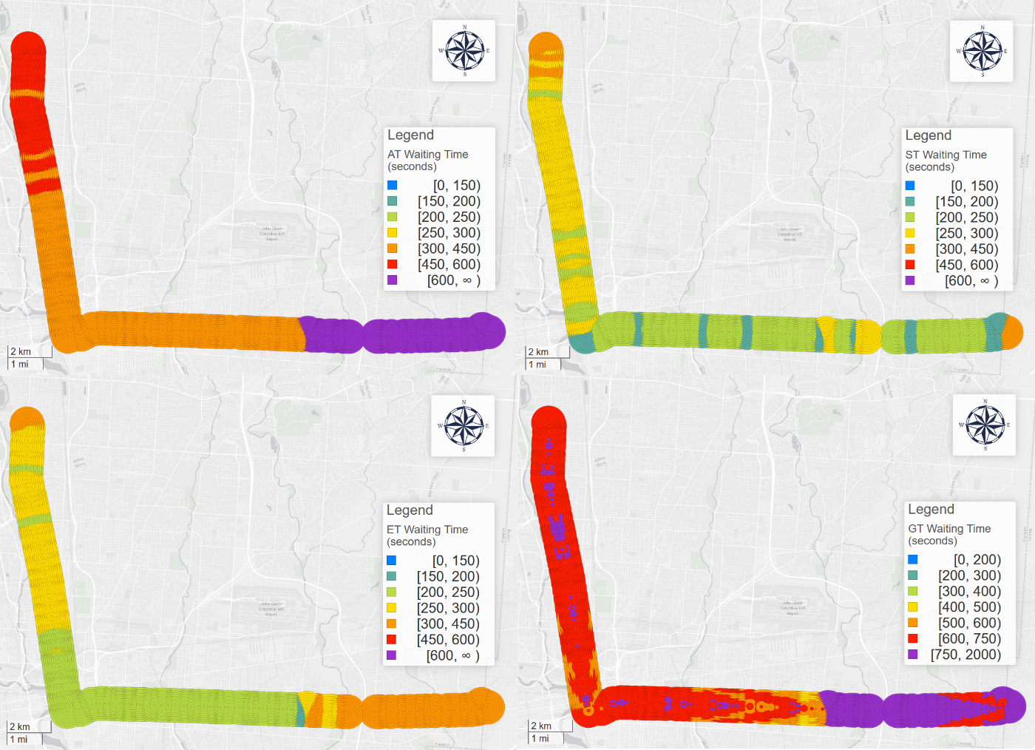

Figure 8 AT (top left), ST (top right), ET (bottom left), GT (bottom right)'s waiting time pattern

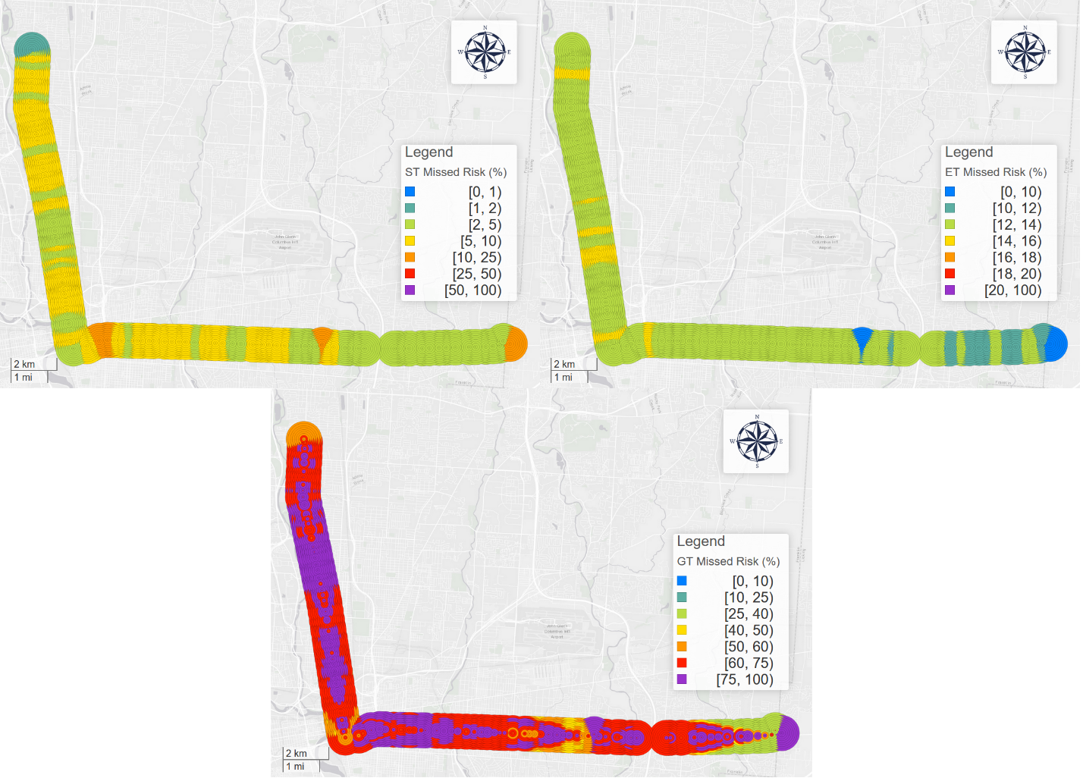

Figure 9 ST (top left), ET with memory (top right), GT (bottom)'s missed risk pattern

**TPS performance with respect to walking time**

Figure 11 illustrates the relationship between waiting time and walking time and Figure 12 shows the relationship between missed risk and walking time. For PT optimal, the longer walking time is, the longer will the user wait and the riskier the user will be to miss the bus. This supports the claim that the longer distance the user lives from the stop, the more unstable their trip becomes. During the longer walking time to the stop, the bus could be more likely to accelerate to catch up the delay, making RTI users miss the target bus.

Figure 11 PT optimal, GT, AT, ET, and ST’s waiting time's relationship with the walking time

Figure 12 PT optimal, GT, ET, and ST’s missed risk's relationship with the walking time

**Spatial differences between ST and PT**. Figure 14 (right) shows the average waiting time difference between ST and PT optimal on COTA bus route No. 2 from Southeast to Northwest. The differences represent the distinction between performance of best non-RTI users (ST) and best RTI users (PT optimal), respectively. We can observe that PT optimal does not outperform ST for all stops. In fact, for most stops, especially for those stops in the upstream near the originating stops, ST’s performance is much better than PT optimal.

We can observe the originating stops have exceptional high waiting time due to larger headway. For most stops, waiting time keeps a relatively low level, but we can hardly observe a stop with an even lower waiting time. This is because IB reduces desynchronization risk when the user catches the bus, but it also makes people wait more time for these synchronized trips. In conclusion, too large (risk-averse) or too small (risk-seeking) buffers all impair the effectiveness of PT optimal, but too small buffers will especially result in desynchronization and suffer more waiting time.

The comparison moreover shows the difference’s highly polarized geographic and temporal patterns. Although PT optimal’s average waiting time is larger than ST’s, the variation of PT optimal is also larger. To moreover prove the variation, geographically, we divide the stops into two groups at stop “North High Street & Euclid Avenue” shown as a grey line in Figure 14; temporally, we divide the whole year by September 1st 2018. The results are shown in Table 2. Upstream stops and time after September had higher waiting time penalty, while downstream stops and before September had lower.

|  |  |  |  |
| --- | --- | --- | --- |
| PT optimal - ST waiting time difference (seconds) | Before Sep 1st 2018 | After Sep 1st 2018 | All year |
| Upstream stops | 1 | 117 | 68 |
| Downstream stops | -91 | 24 | -21 |
| All stops | -32 | 84 | 27 |

Table PT optimal – ST waiting time difference according to different spatiotemporal division

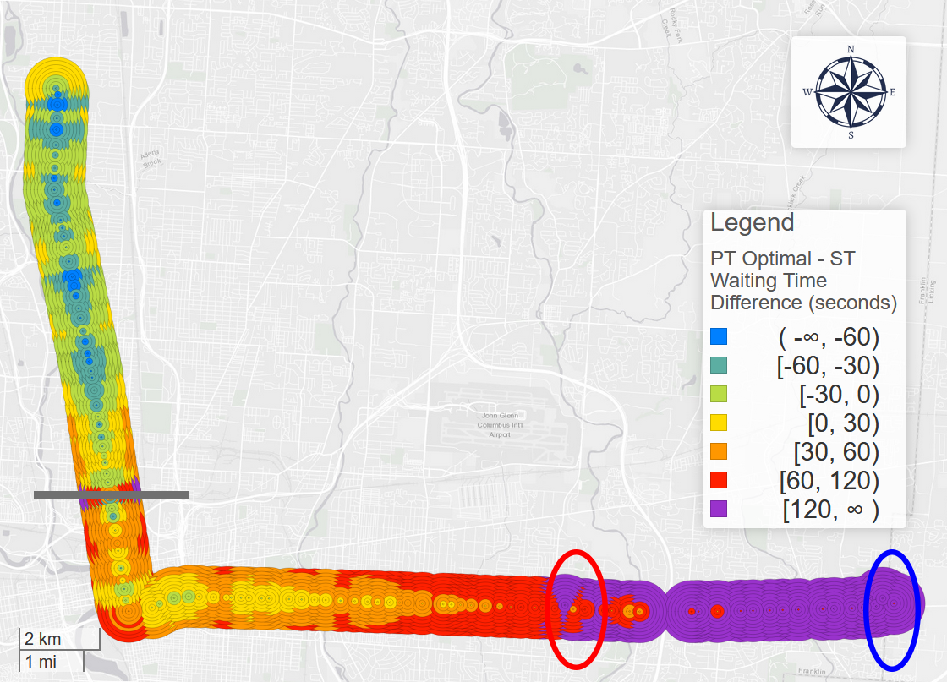

Figure PT optimal – ST waiting time difference for each stop and walking time in COTA bus route No. 2 from Southeast to Northwest in 2018.

**4.5. Other results**

**RTI and marginalized stops.** Figure 13 (left) shows PT optimal’s average waiting time on COTA bus route No.2 from Southeast to Northwest. Noticeably, there are two significant high clusters near the two originating stops (red circled and blue circled) in the standard and frequent No.2 bus schedule. Figure 9 (top left) demonstrates the missed risk for the PT optimal, and it also shows two unnatural high missed risk clusters near the two originating stops.

This is because the lack of real-time data in the very beginning of bus trips. The real-time information will not be available until the bus leaves the originating stop. For certain trips, by the time the real-time information is updated, the user already loses the bus. Under this circumstance, buffer will not help improve the missed risk of such trips since IB’s effectiveness depends on accessible real-time information, and these users are not given the correct real-time data correctly. Meanwhile, users who live far from the stop will have higher missed risk and will consequently suffer from even more waiting time.

Out of the two high clusters, the standard originating stop (blue circled) has higher waiting time. The headway near the standard originating stop (red circled) are larger in the bus schedule. Both the high missed risk and large headways contribute to the unnatural long waiting time at the standard originating stop (blue circled) compared to the frequent originating stop (red circled).

Based on these facts, we can call these stops *marginalized stops*. It suggests that RTI strategies may be less effective at these stops. In these areas, public transit users are vulnerable and may be unable to get real-time information or right information.

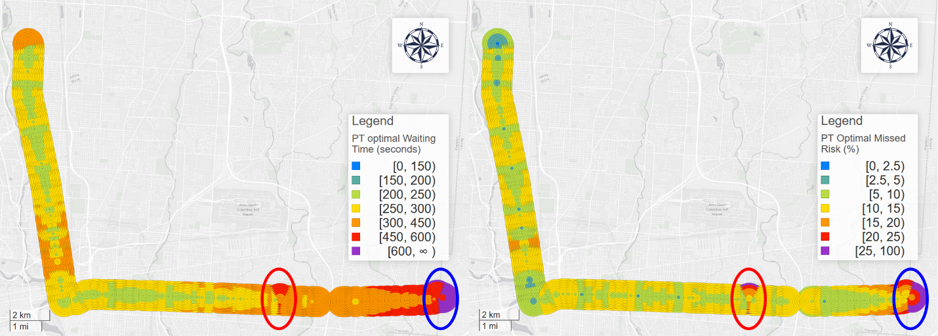

Figure PT optimal’s insurance buffer for each stop and average waiting time in COTA bus route No. 2 from Southeast to Northwest.

**The impacts of service headway.** As previous analyses suggest, headway is a crucial implicit factor for the performance of TPSs. The two temporal analyses also suggest two empirical rules:

* The larger the headways are, the *more* effective PT optimal is, compared to *arbitrary tactic*. This is obvious since AT’s waiting time is exactly the half of the headway. To moreover prove this, we investigated the correlation between the average waiting time difference in each hour and the average headway. The Pearson correlation coefficient is 0.9798 and the p-value is smaller than 0.0001. Figure 19 (left) shows the strong positive correlation between headway of each hour and the waiting time difference. Some former studies also suggested the same conclusion: in rural Scotland, RTI users can save 7 minutes in average (Papangelis et al., 2016), while in other studies in urban areas, the saved time is much less (Brakewood et al., 2014; Chow et al., 2014). RTI will flatten the radical waiting time difference between different systems caused by different scheduled frequencies.
* The larger the headways are, the *less* effective PT optimal is, compared to *scheduled tactic*. Likewise, we tested the correlation between the each hour’s average headway and corresponding performance difference. The Pearson correlation coefficient is -0.6201 and the p-value is 0.0012. Figure 17 (right) is the scatter plot of the two variables. The results show strong negative correlation between headway and the ST - PT waiting time difference.

Figure Scatter plots between Headway and AT/ST - PT optimal waiting time difference

**5. Conclusion**

Many papers have given empirical evidences that real-time information (RTI) and transit RTI apps can decrease transit users’ waiting time (Brakewood & Watkins, 2019). However, few studies systematically investigated the variance of this impact, including spatiotemporal patterns, mechanism of the impact, and optimized the system performance from users’ perspective. In this study, using GTFS real-time data, we first introduce the concept of trip planning strategy (TPS) and five types of TPSs for both RTI and non-RTI users. We also theorize and later validate the concept of reclaimed delay and discontinuity delay during the synchronization process between users and buses. Then, we optimize RTA users’ *prudent tactic* TPS with optimal insurance buffer. Based on different TPSs’ performance, we calculate the waiting time difference between different TPSs and conduct geographic and temporal analysis in different directions and resolutions. The analyses results show that PT optimal users in upstream stops will wait much more time than the ST users, and PT optimal users in this area may suffer from larger missed risk than ST users; also, temporally speaking, PT optimal users are more advantageous during 13:00 – 20:00 than ST users. All the results show that although RTI apps using PT optimal can indeed save time for certain users in certain stops and during certain hours, they cannot achieve global optimality. Moreover, greedy tactic’s performance is the worst among all TPSs despite it is RTI-based. GT’s performance is even worse than the arbitrary tactic. This moreover suggests that RTI apps could make users’ waiting time significantly longer if apps are not using the appropriate trip planning strategy.

The empirical results can provide vital information for transit users, planners, and real-time transit app providers. With more access to real-time data, transit system planning should not only engage with the schedule but also real-time performance; RTI apps development should not only engage with real-time performance but also empirical performance; passengers’ trip planning should not only engage with empirical performance but also all the information above. To achieve these three goals, future RTI apps should be able to combine schedule, real-time, and empirical information into one holistic information, with corresponding computation and networking support.

There are still numerous potentials in both academic and industry area. For example, to improve accuracy and reliability of the public systems and the RTI apps, transit authority or RTI apps providers can add pre-calculated insurance buffers to GTFS data so that RTI apps’ trip planning results inflect transit system’s empirical performance. Meanwhile, the optimization of prudent tactic is not fully explored, as there are unlimited numbers of methods to find the best insurance buffer. Unlike simple non-RTI strategies that can be conceptualized and calculated by human intuition from experience, RTI-based TPSs’ optimization processes should and can only be finished by the backend of the RTI apps, in which more complicated and effective algorithms can be applied. For example, with all the abundant auto-generated data, machine learning and neural network should be able to outperform traditional predicting algorithms.

Moreover, although individual passenger’s performance is systematically discussed in this paper, we do not investigate or simulate the proportions of each user group as Jolliffe & Hutchinson (1975) and Bowman & Turnquist (1981) contributed to the classification and simulation of three classes of passengers with different incidence behaviors. Future research may survey the different user group or the apps provides may disclose statistics of their users, so that RTI apps’ collective impact on the whole population could be calculated.

**Appendix A**

**Optimization problem of prudent strategy’s waiting time.**

We constitute the optimization problem in the following formula.

$\underset{IB_{ijk}}{minimize}{ }:$

|  |  |  |
| --- | --- | --- |
|  | $$δt_{ijk}, ∀i∈Tr, j∈St_{i},k∈[0,K]$$ | (13) |

Subject to:

|  |  |  |
| --- | --- | --- |
|  | $$δt_{ijk}=T\left(t_{ijk}\right)-t_{ijk}$$ | (14) |
|  | $$t_{ijk}=T_{ex}\left(t_{ijk}\right)-δt_{ijk}^{'}=T_{ex}\left(t_{ijk}\right)-IB_{ijk}$$ | (15) |
|  | $$T_{ex}\left(t_{ijk}\right)=T_{ex}^{DD=0}$$ | (16) |
|  |  |  |

Where: $δt_{ijk}$ is the actual waiting time for the user who lives $k$ walking time from the stop $j$ and intends to catch trip $i$. $Tr$ is the collection of all trips, and $St_{i}$ is the stops on trip $i$, $K$ is the designated walking time range. $T(t_{ijk})$ is the actual departure time of target bus, and $t_{ijk}$ is the actual arrival time at the stop for the user. $δt_{ijk}^{'}$ is the expected waiting time as well as the insurance buffer. $T_{ex}^{DD=0}$ is the expected departure time of the scheduled bus.

Reference:

Algers, S., Hansen, S., & Tegner, G. (1975). Role of Waiting Time, Comfort, and Convenience in Modal Choice for Work Trip. *Transportation Research Record*, *534*(534), 38–51.

Bowman, L. A., & Turnquist, M. A. (1981). Service frequency, schedule reliability and passenger wait times at transit stops. *Transportation Research Part A: General*, *15*(6), 465–471. https://doi.org/10.1016/0191-2607(81)90114-X

Brakewood, C., Barbeau, S., & Watkins, K. (2014). An experiment evaluating the impacts of real-time transit information on bus riders in Tampa, Florida. *Transportation Research Part A: Policy and Practice*, *69*, 409–422. https://doi.org/10.1016/j.tra.2014.09.003

Brakewood, C., Macfarlane, G. S., & Watkins, K. (2015). The impact of real-time information on bus ridership in New York City. *Transportation Research Part C: Emerging Technologies*, *53*, 59–75. https://doi.org/10.1016/j.trc.2015.01.021

Brakewood, C., Rojas, F., Zegras, P. C., Watkins, K., & Robin, J. (2015). An analysis of commuter Rail real-time information in Boston. *Journal of Public Transportation*, *18*(1), 1–20. https://doi.org/10.5038/2375-0901.18.1.1

Brakewood, C., & Watkins, K. (2019). A literature review of the passenger benefits of real-time transit information. *Transport Reviews*, *39*(3), 327–356. https://doi.org/10.1080/01441647.2018.1472147

Cabannes, T., Shyu, F., Porter, E., Yao, S., Wang, Y., Sangiovanni Vincentelli, M. A., … Bayen, A. M. (2018). Measuring Regret in Routing: Assessing the Impact of Increased App Usage. *IEEE Conference on Intelligent Transportation Systems, Proceedings, ITSC*, *2018*-*Novem*, 2589–2594. https://doi.org/10.1109/ITSC.2018.8569758

Cats, O., & Gkioulou, Z. (2017). Modeling the impacts of public transport reliability and travel information on passengers’ waiting-time uncertainty. *EURO Journal on Transportation and Logistics*, *6*(3), 247–270. https://doi.org/10.1007/s13676-014-0070-4

Chow, W., Block-Schachter, D., & Hickey, S. (2014). Impacts of real-time passenger information signs in rail stations at the Massachusetts bay transportation authority. *Transportation Research Record*, *2419*(1), 1–10. https://doi.org/10.3114/2419-01

COTA. (2013). C. E. Main. https://doi.org/10.1136/vr.f612

Dutzik, T., Madsen, T., & Baxandall, P. (2013). *A New Way to Go: The Transportation Apps and Vehicle-Sharing Tools that are Giving More Americans the Freedom to Drive Less*. (Fall), 54.

Dziekan, K., & Vermeulen, A. (2006). Psychological Effects of and Design Preferences for Real-Time Information Displays. *Journal of Public Transportation*, *9*(1), 1–19. https://doi.org/10.5038/2375-0901.9.1.1

Fan, Y., Guthrie, A., & Levinson, D. (2016). Waiting time perceptions at transit stops and stations: Effects of basic amenities, gender, and security. *Transportation Research Part A: Policy and Practice*, *88*, 251–264. https://doi.org/10.1016/j.tra.2016.04.012

Ferris, B., Watkins, K., & Borning, A. (2010). OneBusAway: Results from providing real-time arrival information for public transit. *Conference on Human Factors in Computing Systems - Proceedings*, *3*, 1807–1816. https://doi.org/10.1145/1753326.1753597

Fonzone, A., Schmöcker, J. D., & Liu, R. (2015). A Model of Bus Bunching under Reliability-based Passenger Arrival Patterns. *Transportation Research Procedia*, *7*, 276–299. https://doi.org/10.1016/j.trpro.2015.06.015

Fries, R. N., Dunning, A. E., & Chowdhury, M. A. (2011). University traveler value of potential real-time transit information. *Journal of Public Transportation*, *14*(2), 29–50. https://doi.org/10.5038/2375-0901.14.2.2

Frumin, M., & Zhao, J. (2012). Analyzing passenger incidence behavior in heterogeneous transit services using smartcard data and schedule-based assignment. *Transportation Research Record*, *2274*(2274), 52–60. https://doi.org/10.3141/2274-05

Gkioulou, Z. (2013). *Evaluating the impact of waiting time uncertainty on passengers´ decisions*.

Google Developers. (2016). GTFS Static Overview | Static Transit | Google Developers. Retrieved March 8, 2018, from https://developers.google.com/transit/gtfs/

Google Developers. (2018). Trip Updates. Retrieved April 8, 2019, from https://developers.google.com/transit/gtfs-realtime/guides/trip-updates

Goyder, J. (1986). Surveys on Surveys: Limitations and Potentialities. *Public Opinion Quarterly*, *50*(1), 27. https://doi.org/10.1086/268957

Jolliffe, J. K., & Hutchinson, T. P. (1975). Behavioural Explanation of the Association Between Bus and Passenger Arrivals At a Bus Stop. *Transportation Science*, *9*(3), 248–282. https://doi.org/10.1287/trsc.9.3.248

Larsen, O. I., & Sunde, Ø. (2008). Waiting time and the role and value of information in scheduled transport. *Research in Transportation Economics*, *23*(1), 41–52. https://doi.org/10.1016/j.retrec.2008.10.005

Liu, L., & Miller, H. J. (2019). Measuring public transit transfer risk using high-resolution schedule and real-time bus location data. *Manuscript Submitted for Publication.*

Liu, Y., Shi, J., & Jian, M. (2017). Understanding visitors’ responses to intelligent transportation system in a tourist city with a mixed ranked logit model. *Journal of Advanced Transportation*, *2017*. https://doi.org/10.1155/2017/8652053

Neuman, W. L., & Robson, K. (2004). *“Basics of social research. Pearson.”* Pearson Canada Toronto.

Papangelis, K., Nelson, J. D., Sripada, S., & Beecroft, M. (2016). The effects of mobile real-time information on rural passengers. *Transportation Planning and Technology*, *39*(1), 97–114. https://doi.org/10.1080/03081060.2015.1108085

Park, Y., Mount, J., Liu, L., Xiao, N., & Miller, H. J. (2019). Assessing public transit performance using real-time data: spatiotemporal patterns of bus operation delays in Columbus, Ohio, USA. *International Journal of Geographical Information Science*, 1–26. https://doi.org/10.1080/13658816.2019.1608997

Reed, T. B. (1995). Reduction in the burden of waiting for public transit due to real-time schedule information: a conjoint analysis study. *Vehicle Navigation and Information Systems Conference (VNIS)*, 83–89. IEEE.

Transit app. (2019). How we shrank our trip planner till it didn’t need data. Introducing public transit’s fastest, tiniest, offline-capable trip planner. Retrieved December 5, 2019, from https://medium.com/transit-app/how-we-shrank-our-trip-planner-till-it-didnt-need-data-84984ca56663

Walker, J. (2012). Human transit: How clearer thinking about public transit can enrich our communities and our lives. In *Human Transit: How Clearer Thinking About Public Transit can Enrich our Communities and our Lives*. Island Press.

Watkins, K. E., Ferris, B., Borning, A., Rutherford, G. S., & Layton, D. (2011). Where Is My Bus? Impact of mobile real-time information on the perceived and actual wait time of transit riders. *Transportation Research Part A: Policy and Practice*, *45*(8), 839–848. https://doi.org/10.1016/j.tra.2011.06.010

Wilcox, J. B., Rossi, P. H., Wright, J. D., & Anderson, A. B. (1985). Handbook of Survey Research. In *Journal of Marketing Research* (Vol. 22). https://doi.org/10.2307/3151558

Wright, K. B. (2006). Researching Internet-Based Populations: Advantages and Disadvantages of Online Survey Research, Online Questionnaire Authoring Software Packages, and Web Survey Services. *Journal of Computer-Mediated Communication*, *10*(3), 00–00. https://doi.org/10.1111/j.1083-6101.2005.tb00259.x